ERD for SEO

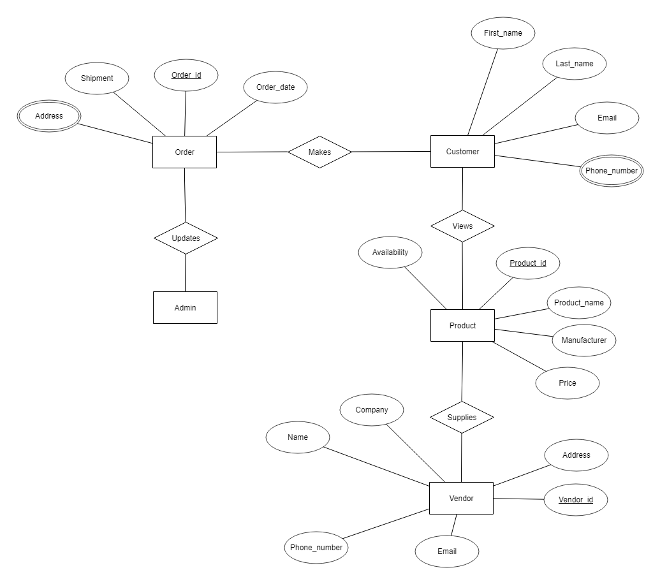

**Entities:** Order, Customer, Product, Vendor, Admin

**Attributes:**

* VENDOR: Company, name, phone_number, email, vendor_id, address
* PRODUCT: Availability, product_id, price, manufacturer, product_name
* CUSTOMER: first_name, last_name, address, email, phone_number
* ORDER: order_id, shipment, address, order_date